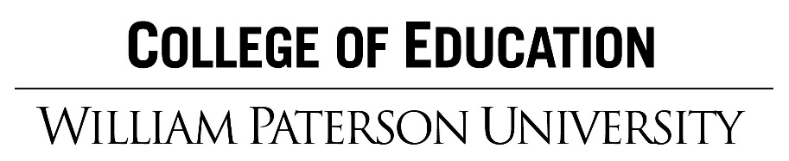

College and Career Ready Practices

New Jersey Student Learning Standards includes Standard 9: 21st Century Life and Career, which can be integrated and practiced into all content areas. These standards were to prepare students to be lifelong learners who have the knowledge and skills to adapt to an evolving workplace and world. Standard 9, 21st Century Life and Careers, includes 12 Career Ready Practices, with clear guidelines for what students need to know and be able to do in order to be successful in their future careers within the 21st century.
How are you integrating and having students practice Career Ready Practices in your lessons?
21st Century Life and Career Standard 9 Overview: http://www.state.nj.us/education/cccs/2014/career/
Career Ready Practices: http://www.state.nj.us/education/cccs/2014/career/CareerReadyPractices.pdf
Career Ready Practices Poster: http://www.state.nj.us/education/cte/hl/CRP.pdf

12 Career Ready Practices
CRP1. Act as a responsible and contributing citizen and employee.
CRP2. Apply appropriate academic and technical skills.
CRP3. Attend to personal health and financial well-being.
CRP4. Communicate clearly and effectively and with reason.
CRP5. Consider the environmental, social and economic impacts of decisions.
CRP6. Demonstrate creativity and innovation.
CRP7. Employ valid and reliable research strategies.
CRP8. Utilize critical thinking to make sense of problems and persevere in solving them.
CRP9. Model integrity, ethical leadership and effective management.
CRP10. Plan education and career paths aligned to personal goals.
CRP11. Use technology to enhance productivity.
CRP12. Work productively in teams while using cultural global competence.

